Unit 15:

Writing part 7



41. in 42. Like 43. Much 44. How 45. You 46. On 47. Costs/ is 48. To 49. A 50. This 



41. to 42. With 43. At 44. We 45. This 46. To 47. Am



**48. ask/ tell 49. You 50. About**

**Practice 7:**

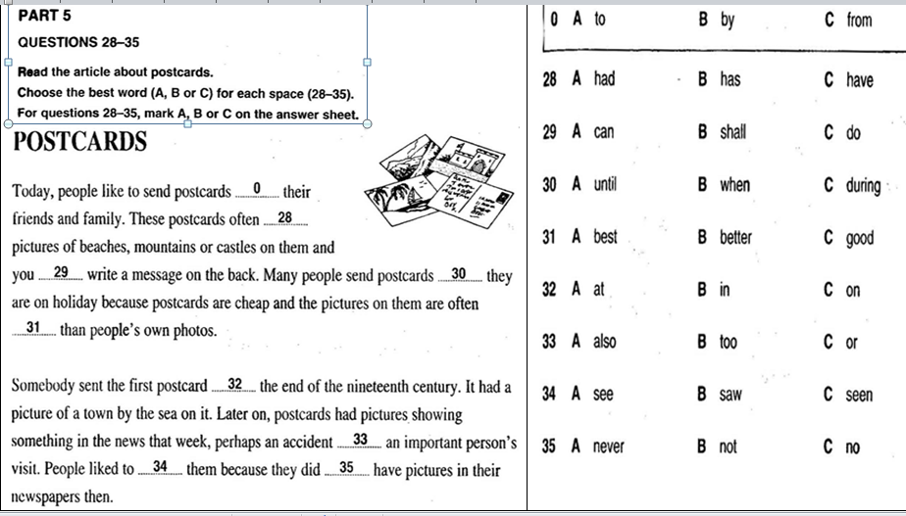

Send st to sb = send sb st: gui cho ai cai gi

In the end, = finally,

At the end of

|  |  |
| --- | --- |
| So, do do, do vay, vi vay  Because: boi vi | Use: su dung, dung (st/sb)  Used to Vnd: thuong lam gi trong qua khu |

PART 9:

|  |  |
| --- | --- |
|  | Dear Jools, |

Thanks for your email. As you know, yesterday I went to the music club. It is in my university. It is every Sunday. I play the guitar there.

Write to me soon.

UNIT 6

|  |  |
| --- | --- |
|  |  |

|  |  |
| --- | --- |
|  | More boring – the most boring  Faster – the fastest  More beautiful – the most beautiful  More expensive – the most expensive  Thinner – the thinnest  More popular – the most popular  Bigger – the biggest  Happier – the happiest |

Vocabulary: Free time activities

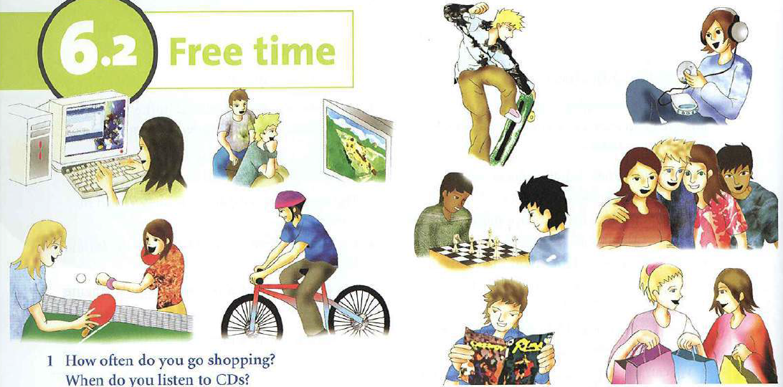

Free time activities:

Play games / watch TV/ skateboard/ listen to music/ play table tennis/ ride a bike/ play chess/ read a book/ talk to sb/ go shopping.

Questions:

What do you often do in your free time?

= what is your hobby? = what do you usually do when you have free time? = what do you like doing in your free time?

* I like Ving ( HTD) watching TV, listening to music….

|  |  |
| --- | --- |
| LISTENING | 1. 10 2. 50   3. GLENDENNAN  4. ice cream  5. books |

HUONG DAN PHAN DOC SO 2 – READING PART 2: (A/B/C)

* Kiem tra ve ngu phap va tu vung la chu yeu.
* 6-10 (5 cau)
* Ve 1 chu de cu the (gach chant u dung sau tu about trong de bai)
* Doc tu dung sau va tu dung truoc cho trong, dua ra dap an.
* Doc ca cau xem noi dung cau noi ve gi?

VISITING A FARM.

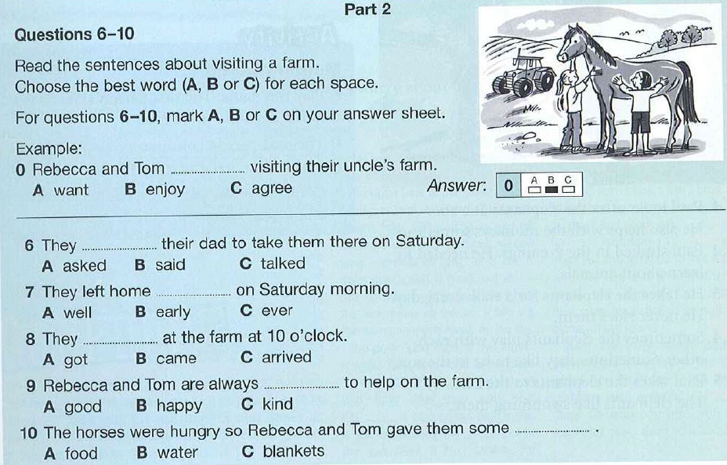

Ask Sb to Vnd: bao ai lam gi / at ?? get to / come to – arrive at/ in

Happy – food

Say said to SB.

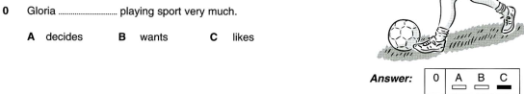

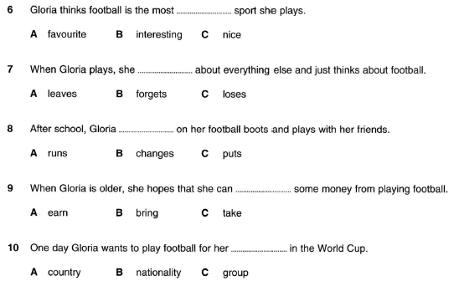

Bring = take money

Make = earn money